## REPORT’22

## STUDENT’S SEMESTER PROJECT

### 

### **PRESENTED BY:-**

1. **SANA KHALID (21K-3421)**
2. **FIZZA RASHID (21K-3390)**

# OBJECTIVE:-

* Allows teacher to login before entering the portal.
* Allows teacher to maintain semester report student wise.

🡺 Teacher can add students.

🡺 Teacher can view details.

🡺 Teacher can modify data.

🡺 Teacher can delete the expire data.

* Allows Student to search and view his/her semester report.
* Student can utilise CGPA/GPA calculator based on credit hours effectively.

FEATURES OF OOP IMPLEMENTED:-

1. ‘Classes’ and ‘objects’ are used.
2. ‘File handling’ feature is applied.
3. ‘Inheritance’ feature is implemented.

SNAPSHOTS OF IMPLENTATION:-

* **MAIN MENU:-**

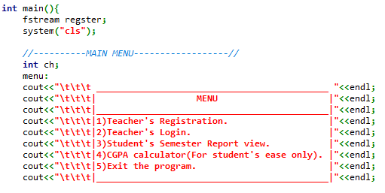

* **MAIN FUNCTIONS() :-**

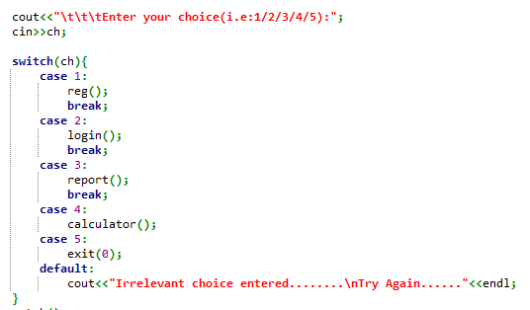

* **REGISTRATION FUNCTIONALITY🡪 “reg()”**

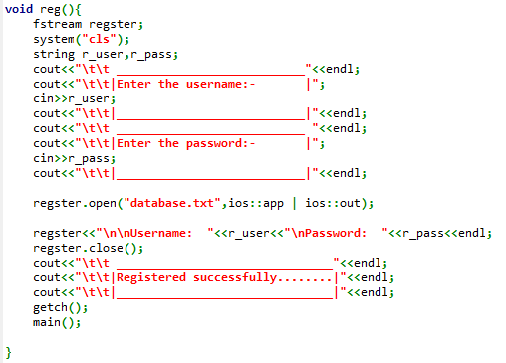

* 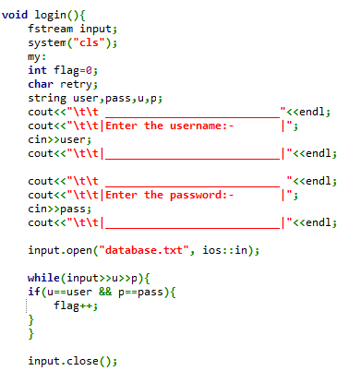**LOGIN TEACHER PORTAL🡪”login()”**
* **CONTINUED:-**

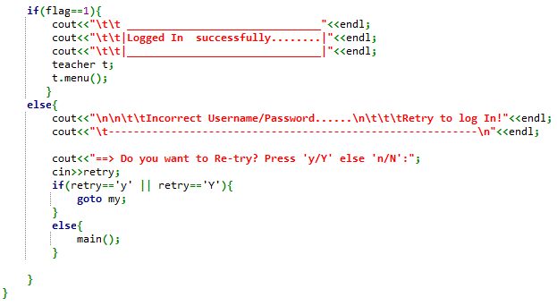

* **STUDENT’S VIEW🡪”report()”**

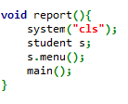

* **CGPA/GPA CALCULATOR🡪”calculator()”**

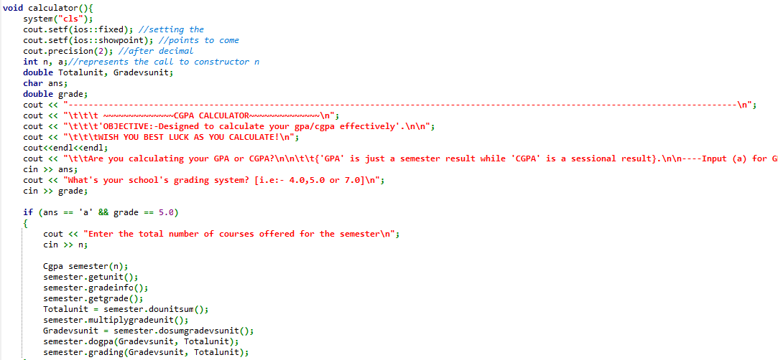

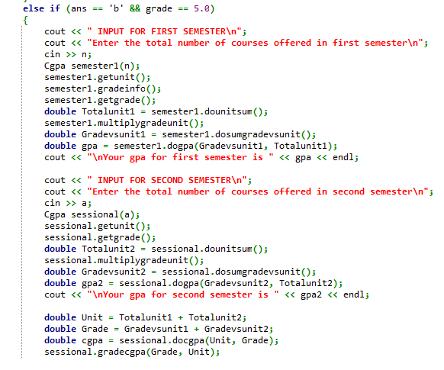

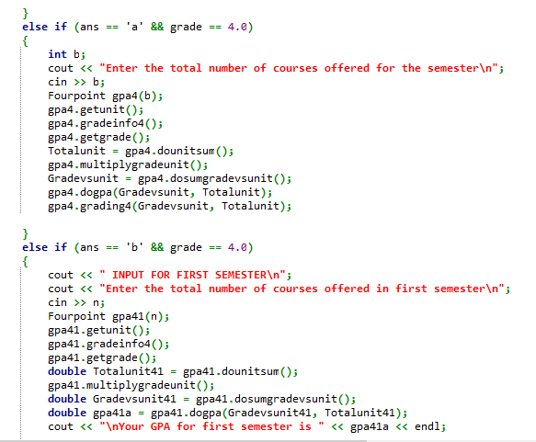

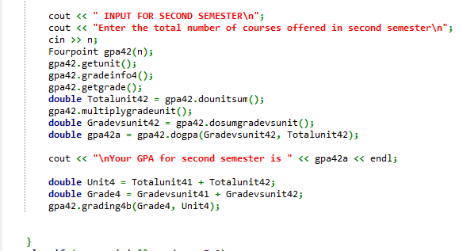

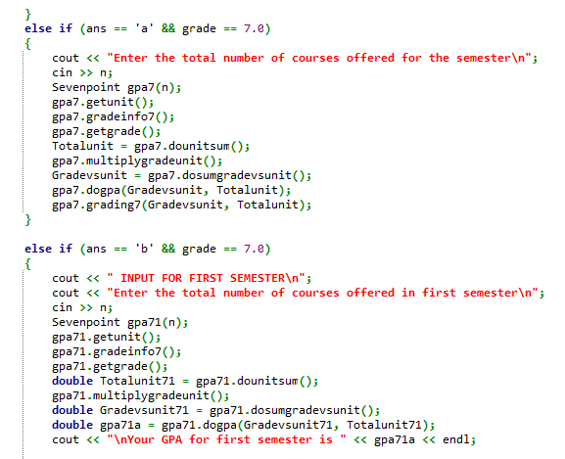

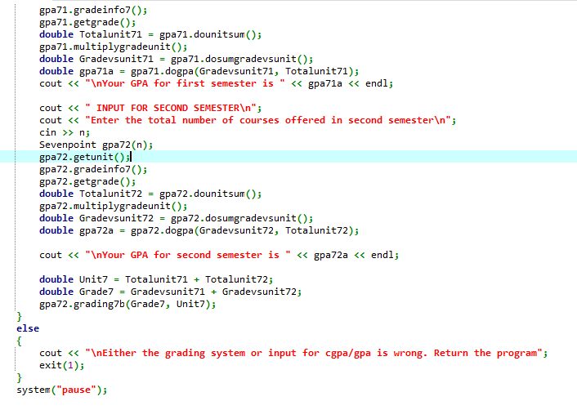

<TEACHER’S PORTAL TO UPDATE STUDENT’S DATA>

🡪CLASS “TEACHER”:

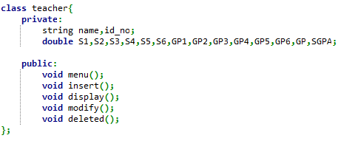

🡺 **menu ():**

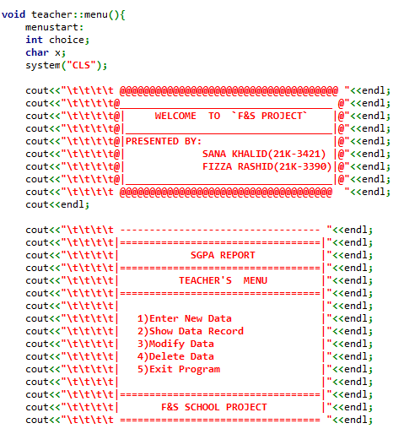

🡺**Functionalities inside main :**

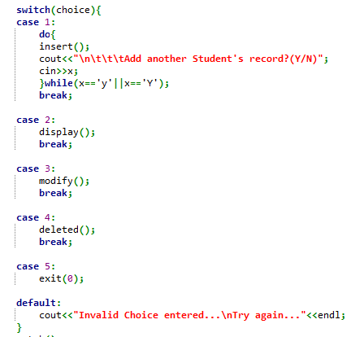

* 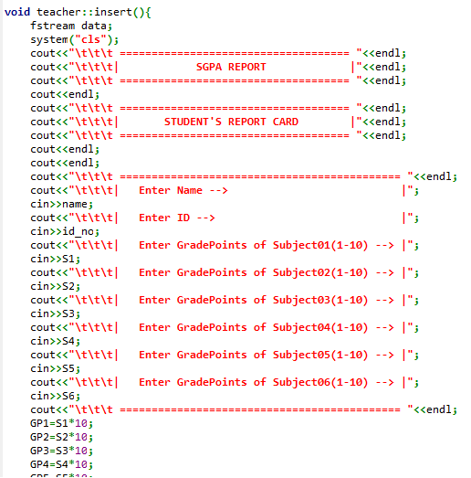**Insert () :**

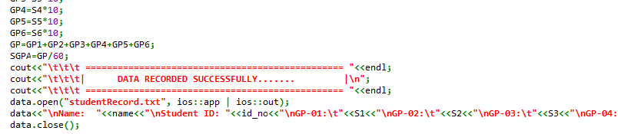

* **Display () :**

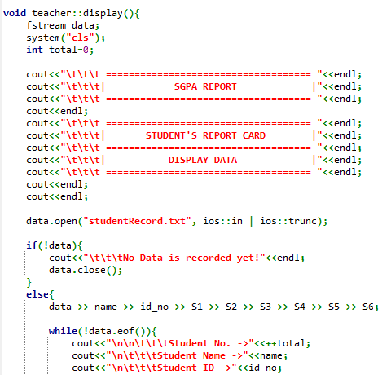

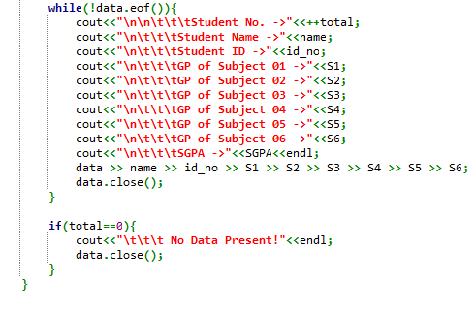

* **Modify () :**

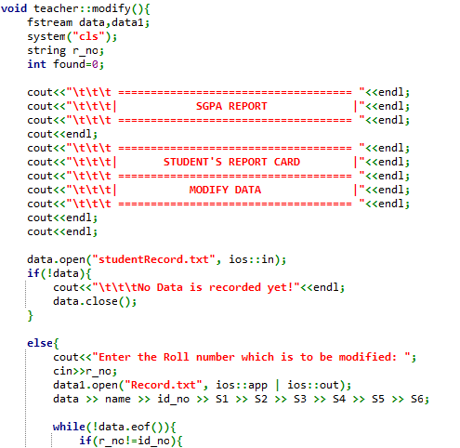

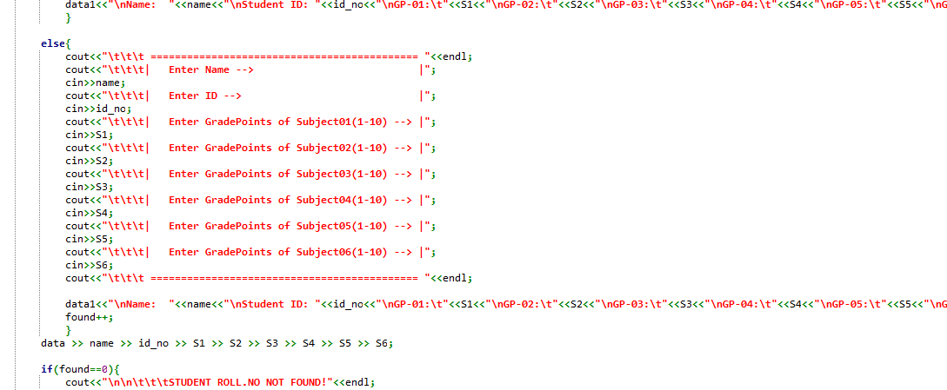

* **Deleted () :**

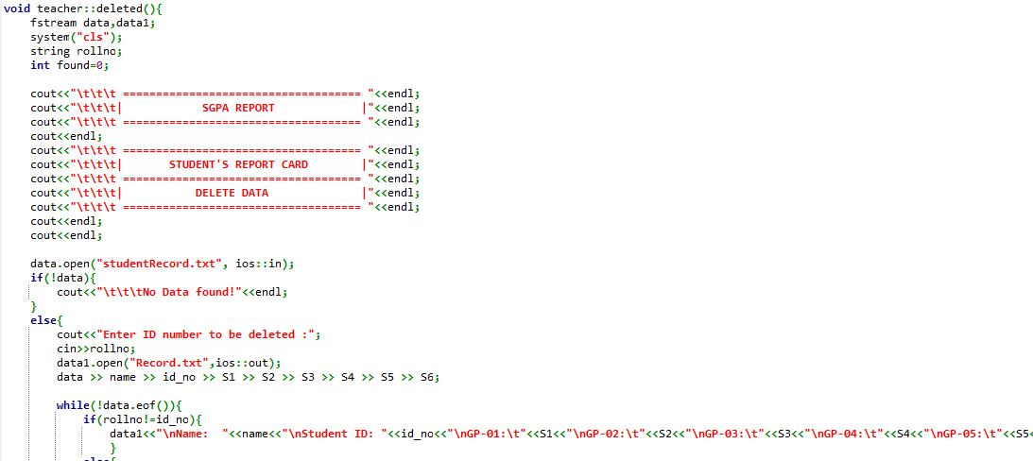

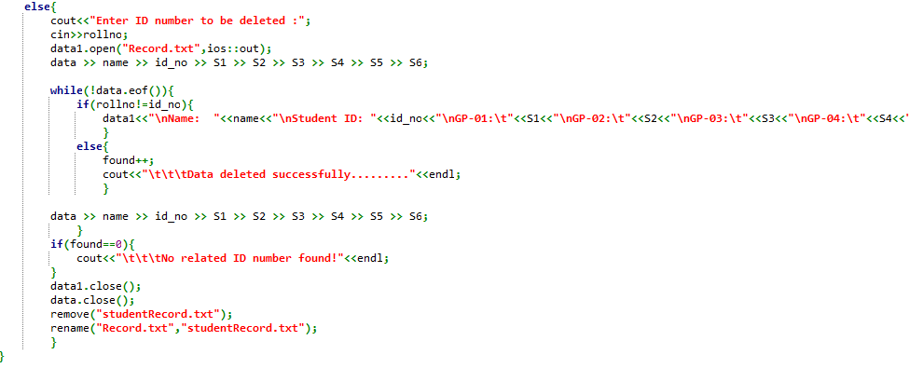

<STUDENT’S PORTAL TO VIEW STUDENT’S DATA>

🡪CLASS “STUDENT”:

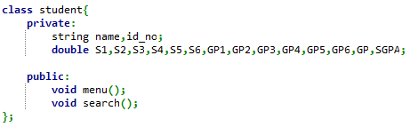

🡺 **menu ():**

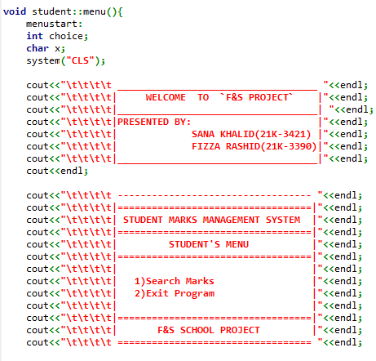

* **Search () :**

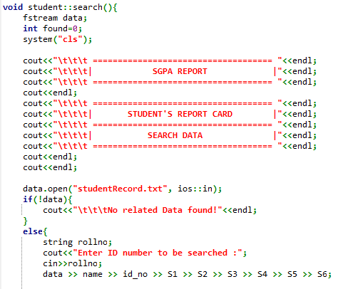

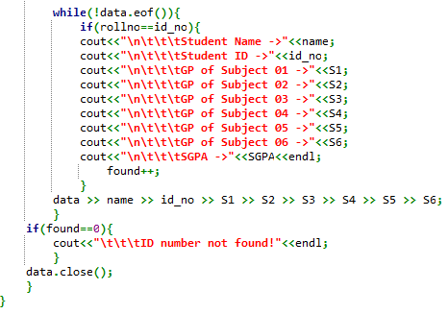

<STUDENT’S PORTAL TO CALCULATE STUDENT’S GPA/CGPA>

🡪CLASS “CGPA”:

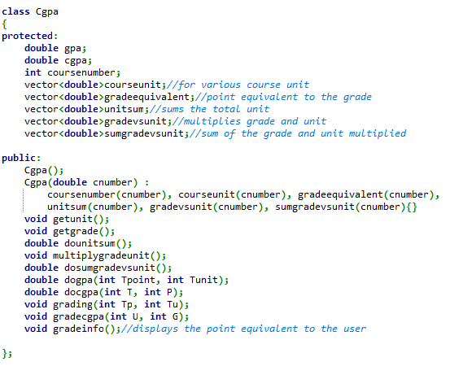

<LIBRARIES USED IN THE PROJECT>

